# The ISP Column

*A column on various things Internet*

|  |
| --- |
| January 2025 |

Geoff Huston

# BGP Updates in 2024

The first part of this annual report on BGP for the year 2024 looked at the size of the routing table and some projections of table growth for both IPv4 and IPv6. However, the scalability of BGP as the Internet’s routing protocol is not just dependant on the number of prefixes carried in the routing table. BGP protocol behaviour in the form of dynamic routing updates are also part of this story. If the update rate of BGP is growing faster than we can deploy processing capability to match, then the routing system will lose coherence, and at that point the network will head into periods of instability. This report looks at the profile of BGP updates across 2023 to assess whether the stability of the routing system, as measured by the level of BGP update activity, is changing.

### IPv4 Stability

Figure 1 shows the daily BGP update activity as seen from a vantage point located in AS131072, since mid-2009.

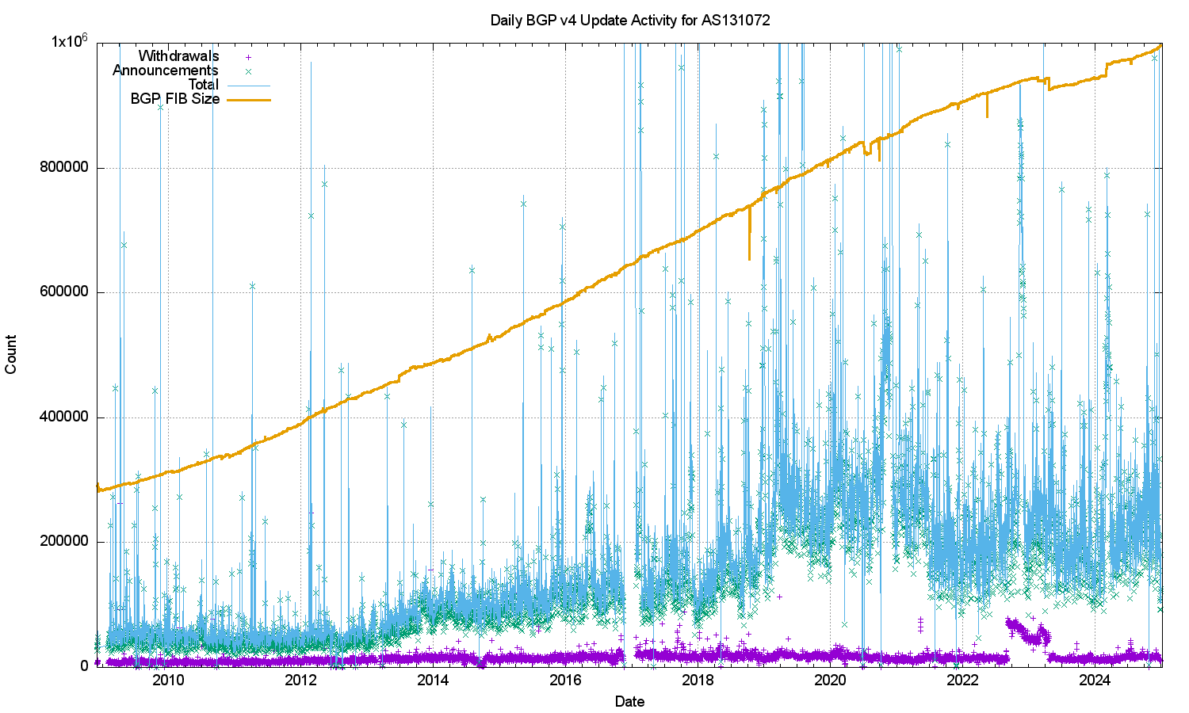

*Figure 1 – IPv4 BGP update counts*

The number of observed BGP withdrawal messages per day (shown in violet in Figure 1) has remained relatively constant at some 15,000 – 20,000 withdrawals per day up until mid-2022. The daily rate increased to some 75,000 withdrawals at that time and then resumed the prior behaviour across most of 2023 and 2024. The total number of advertised IPv4 prefixes has risen from 300,000 to 1,000,000 in the period from the start of 2011 until the end of 2024 (shown in orange in Figure 1). There is no particular reason why the daily withdrawal count should be steady while the number of announced prefixes has tripled. If withdrawals are a result of some form of link-based isolation event at the origin of the announcement, then one would expect that as the number of networks increases the withdrawal volume would also increase proportionately, but this is not what we see in BGP. The withdrawal rate also appears to be unrelated to either the number of routed prefixes or the number of routed networks.

The number of update messages per day (shown in green in Figure 1) has not been as constant. This was steady at some 50,000 updates per day from 2009 until 2013. During 2013 the volume of updates grew to some 100,000 updates per day, which it maintained for most of the ensuing 24 months. During 2018 the number of updates per day rose again, approaching some 250,000 updates per day by the end of 2018. The update count remained around this level until the start of 2021. Through 2021 the update rate has declined to an average value of around 200,000 updates per day. It has fallen further to some 180,000 updates per day through 2023, rising again to slightly over 200,000 updates per day in 2024. To illustrate these trend movements in the BGP update rate, a smoothed average of the daily update count is shown in Figure 2.

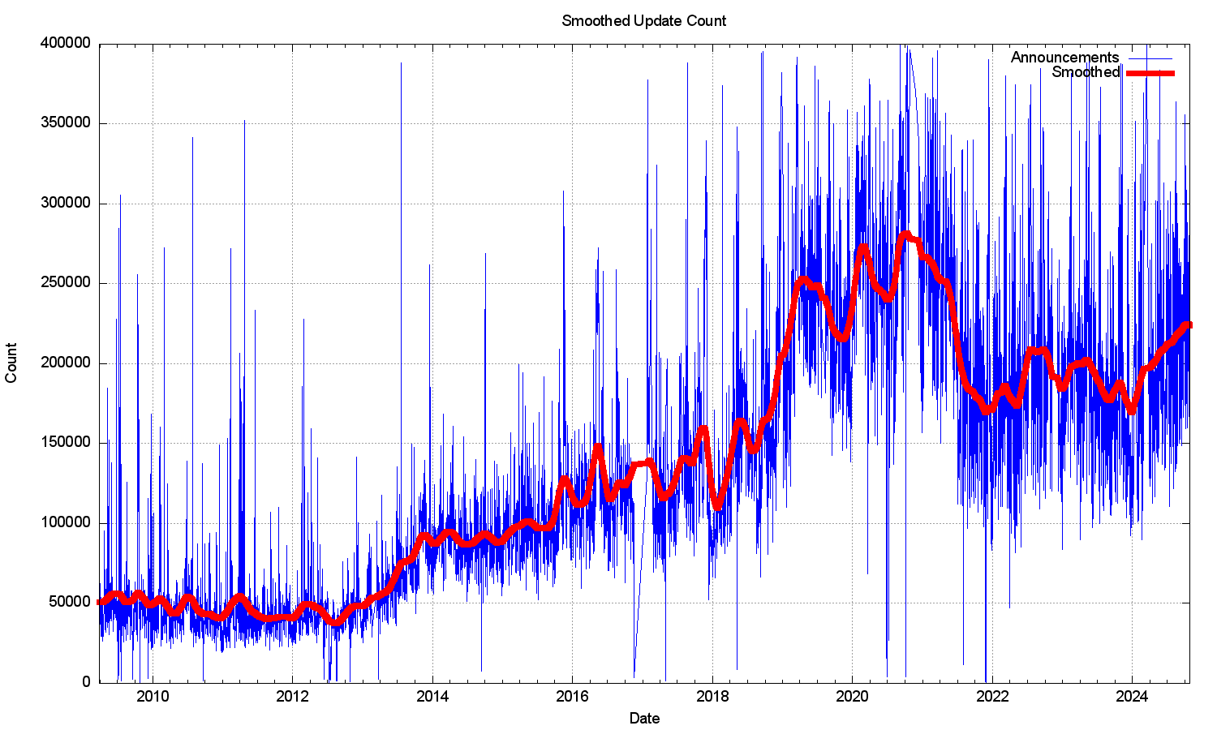

*Figure 2 – Smoothed IPv4 BGP prefix update counts*

It has been fortuitous that the BGP update rate had been held steady for so many years, as this has implied that BGP routers that operate in the default-free *core* of the Internet does not require constantly increasing processing capability. In the same way that there is no clear understanding of why the BGP update rate was steady for so many years, it’s also unclear why the rate increased and then declined in recent years.

What is also intriguing is that most of these prefix update messages are generated from a pool of between 30,000 to 80,000 prefixes. A plot of the daily count of prefixes that are the subject of BGP updates is shown in Figure 3. While this number is rising, it is not rising at the same rate as the number of updates per day, so the heightened instability is possibly to be due to more updates to reach convergence, rather than due to more unstable prefixes. Another possible explanation is that we are looking at daily average numbers, and this rise in the average could be caused by a small pool of unstable prefixes exhibiting higher levels of instability than was the case previously.

*Figure 3 – IPv4 unstable prefixes per day*

The number of unstable prefixes per day appears to be gradually increasing over the years. A least-squares best fit shows a linear trend where the average daily unstable prefix count is increasing by some 400 prefixes per year. This is far lower than the trend in the increase in the size of the FIB table.

The long-term trend of an increasing count of the number of unstable prefixes and the increasing update count is not reflected in the measure of the average time for the routing system to reach a converged state following a prefix update. This daily average time for an unstable prefix to reach stability is currently between 25 and 35 seconds (Figure 4). There was a period of elevated instability in 2019 – 2020 where the average convergence time rose to 80 seconds, it has since stabilised to a time of 45 seconds for the latter half of 2022, and then dropped further in 2024.

*Figure 4 – IPv4 Average routing convergence time per day*

The instability in BGP is not uniform. Half of all BGP updates over a period of December 2024 are attributed to less than 5% of the unstable prefixes, and just 50 origin ASNs accounted for one third of all BGP IPv4 updates in this period. It appears that the network is generally highly stable, and that a very small number of prefixes appear to be announced with highly unstable BGP configurations over periods that extend for weeks rather than hours. The cumulative distribution of BGP updates by prefix and by origin AS, shown in Figures 5 and 6, illustrates the highly skewed nature of unstable prefixes in the routing system. What is also of interest is that the ASN distribution is more “skewed” than that of the prefix distribution. This would tend to suggest that the cases of high update volume are generated at the network level rather than the individual prefix level.

*Figure 5 – Distribution of BGP Updates by Prefix Figure 6 – Distribution of BGP Updates by Origin AS*

### IPv6 Stability

Ideally, the IPv6 routing network should be behaving in a very similar manner to the IPv4 environment. It’s a smaller network, but the underlying connectivity for IPv6 should be essentially similar in terms of the connectivity of IPv4 (it would be unusual to see two networks where one provided transit services to the other in IPv4, yet the opposite arrangement is used for IPv6). So, given that the underlying topology should have strong elements of similarity across the two protocols, we should see the BGP stability profile of IPv6 appear to be much the same as IPv4.

However, this is not the case. Figure 7 shows the profile of IPv6 updates since 2009. The IPv6 BGP network appears to be far “noisier” as compared to the IPv4 network. The number of withdrawals and updates appear to follow the total size of the IPv6 FIB table. Until 2022 the number of updates per day grew at the same rate as the total number of advertised IPv6 prefixes, for the past 24 months both the total number of updates per day, and the total number of withdrawals per day have neem held at a constant level.

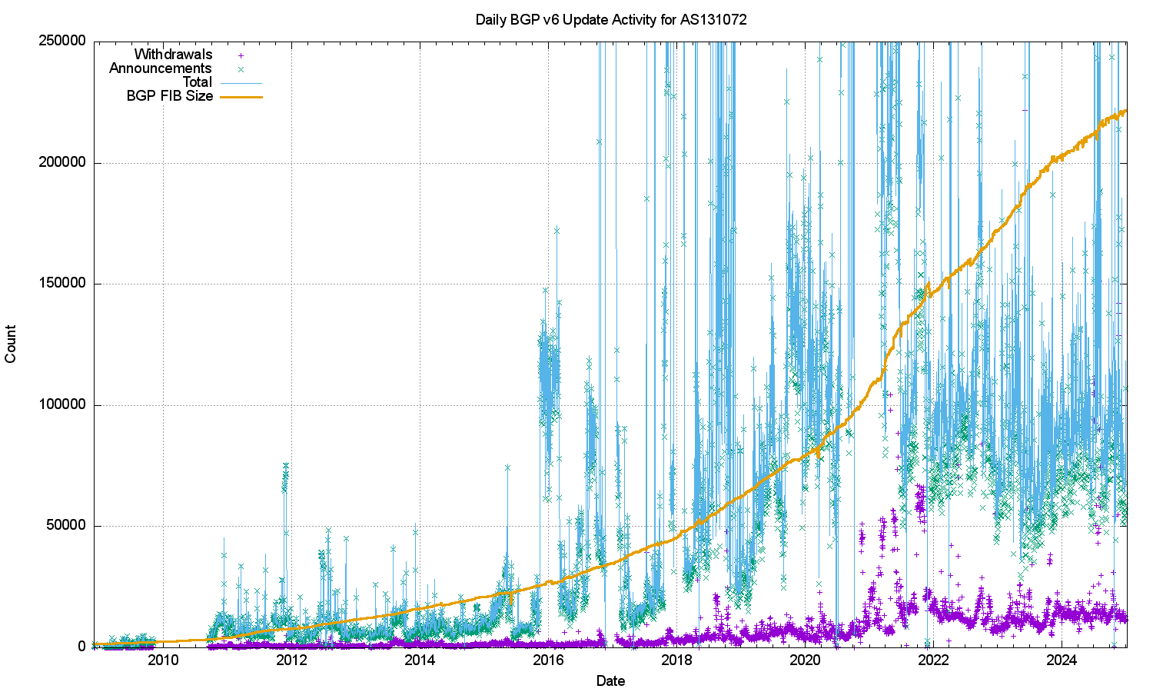

*Figure 7 – IPv6 BGP update counts*

The large span of this data can be better represented using a log scale for the daily counts, as shown in Figure 8. It is evident in Figure 9 that the exponential growth trends in the IPv6 network (which are shown as linear growth in a log-scale plot) came to an end in late 2022 asmd while the FIB table size has continued to grow the number of daily updates and withdrawals has remained largely static since then.

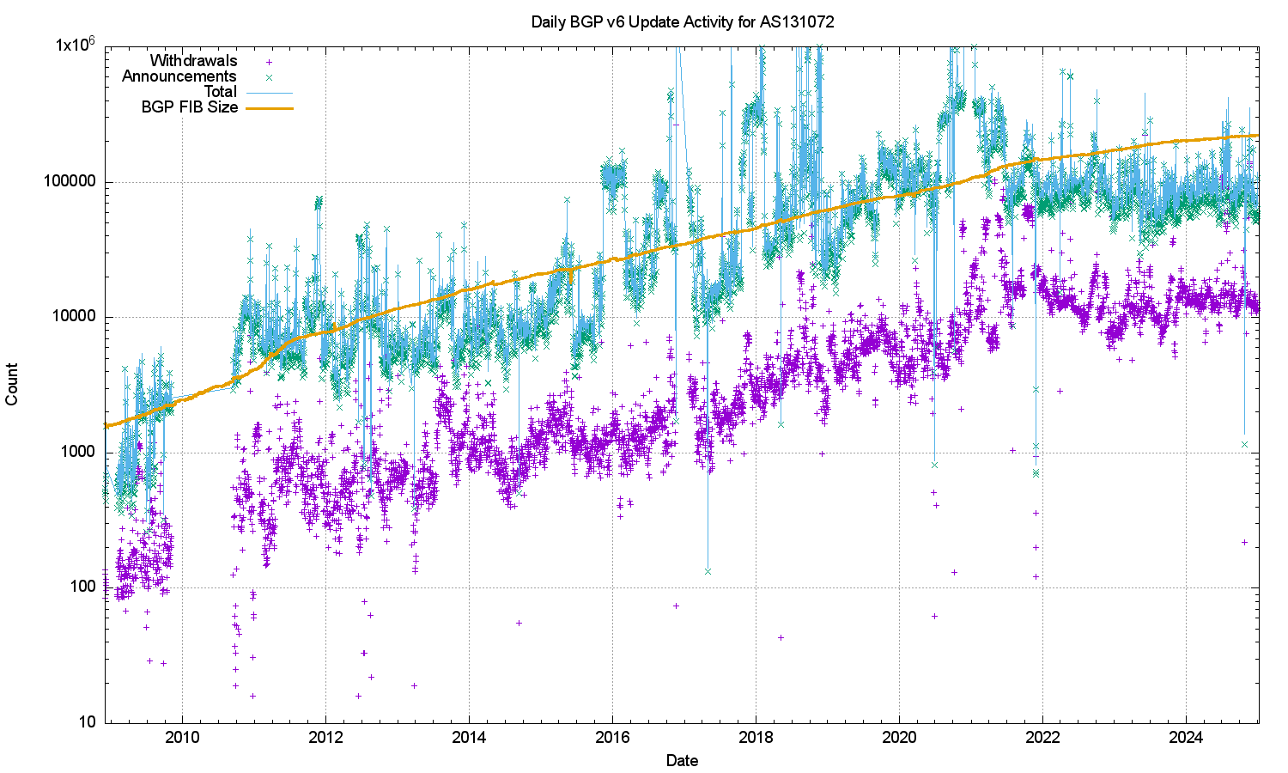

*Figure 8 – IPv6 BGP update counts – log scale*

A smoother daily update count in shown in Figure 10, which clearly shows the daily update count in a band of between 5,000 to 10,000 updates per day for the most recent three years.

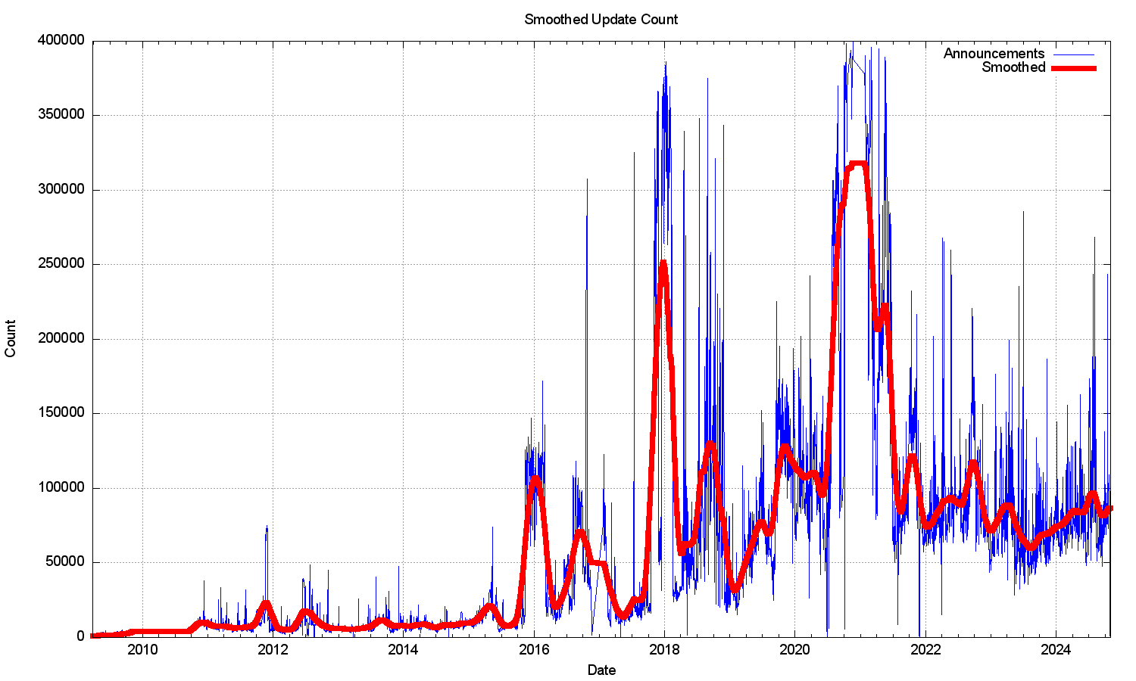

*Figure 9 – Smoothed IPv6 BGP prefix update counts*

Figure 10 shows that the number of unstable prefixes has been tracking the total IPv6 table count, with some 10% of announced prefixes being updated each day. This jumped to 20% of announced prefixes at the start of 2018. The high count of updated prefixes suggests a topology-based oscillation in one of the upstream feeds for this network that appears to affect a large subset of the total count of prefixes in the IPv6 routing table. This increased instability was addressed in late 2022, and the pattern for the past 24 months is ponce more at some 10% of announced prefixes. The number of withdrawals per day has been relatively steady at around 10,000, and the number of daily updates between 60,000 to 100,000.

A comparison between the unstable prefix count in IPv4 (Figure 3) and that of IPv6 (Figure 10) is interesting. Both networks share a common transmission infrastructure and as the use of infrastructure tunnels has largely stopped in IPv6, the underlying interconnection topologies are largely similar. An issue with running two discrete routing systems within the Internet is that it is sometimes the case that operational attention remains fixated on the IPv4 routing system, while IPv6 is simply assumed to be working. Routing pathologies in the IPv6 network appear to remain unnoticed for many months, and for the end user level the dual stack environment simply masks the issues. Failure to connect in IPv6 is silently fixed in applications’ Happy Eyeballs behaviour mode by rapidly switching to use IPv4 for the affected sessions when IPv6 reachability is impaired in some way.

*Figure 10 – Unstable IPv6 Prefix Count – log scale*

The average time to reach convergence has been highly unstable for the IPv6 network until late 2022. The daily average of this convergence time across 2023 and 2024 has been stable, and for the first time for IPv6 is now comparable to the IPv4 convergence performance, ranging between 40 and 50 seconds (Figure 11). A likely reasons for this is the decline in use of infrastructure tunnelling in the IPv6 network.

*Figure 11 – IPv6 Average Routing Convergence time per day*

The distribution of updates in IPv6 is more skewed than that of IPv4. The distribution of updates in IPv6 and IPv6 is shown in Figures 12 and 13. In December 2024, the “noisiest” 0.1% of ASes in IPv6 are associated with 70% of all updates seen in the month, while the most active 0.1% of prefixes are associated with 15% of all updates. AS25145 (Teknotel Telecommunications, Turkie) is the source of much of the current instability, while the two most unstable prefixes are originated by AS2216 (Zscaler, US) and AS35661 (VIRTUASYS, France).

*Figure 12 – Distribution of BGP IPv6 Updates by Prefix Figure 13 – Distribution of BGP IPv6 Updates by Origin AS*

It is not immediately obvious why IPv6 has more skewed instability component than IPv4. A lingering concern is that this instability remains a persistent condition as the IPv6 network continues to grow, which would create a routing environment that would impose a higher processing overhead than we had anticipated, with its attendant pressures on BGP processing capabilities in the network.

### Instability and Topology

BGP is a distance vector routing protocol that achieves a coordinated stable routing state through repeated iterations of a local update protocol. The efficiency of the protocol depends heavily on the underlying topology of the network. Highly clustered topologies, such as star-based topologies, will converge quickly, whereas arbitrary mesh-based topologies will generally take longer to converge to a stable state.

The convergence behaviour of BGP, particularly in the IPv4 network is quite remarkably good, and perhaps the best illustration of why this is the case lies in the average AS Path length of the IPv4 BGP routing table over time (Figure 14).

*Figure 14 – Average AS Path Length of BGP IPv4 prefixes*

A related picture is shown in the distribution of AS Adjacency counts in the V4 network (Figure 15). Only 9 networks have more than 1,000 AS adjacencies that are advertised to the transit network. This is consistent with a network that is composed of a relatively small set of transit “connectors” and a far larger set of stub networks that attach themselves into this core.

*Figure 15 – Distribution of AS Adjacencies in the V4 network*

A similar picture exists in IPv6 (Figure 16) of a relatively stable average AS Path length, and there is a similar picture of AS Adjacency distribution (Figure 17). In the case of IPv6 there are other factors that appear to influence the overall stability of IPv6.

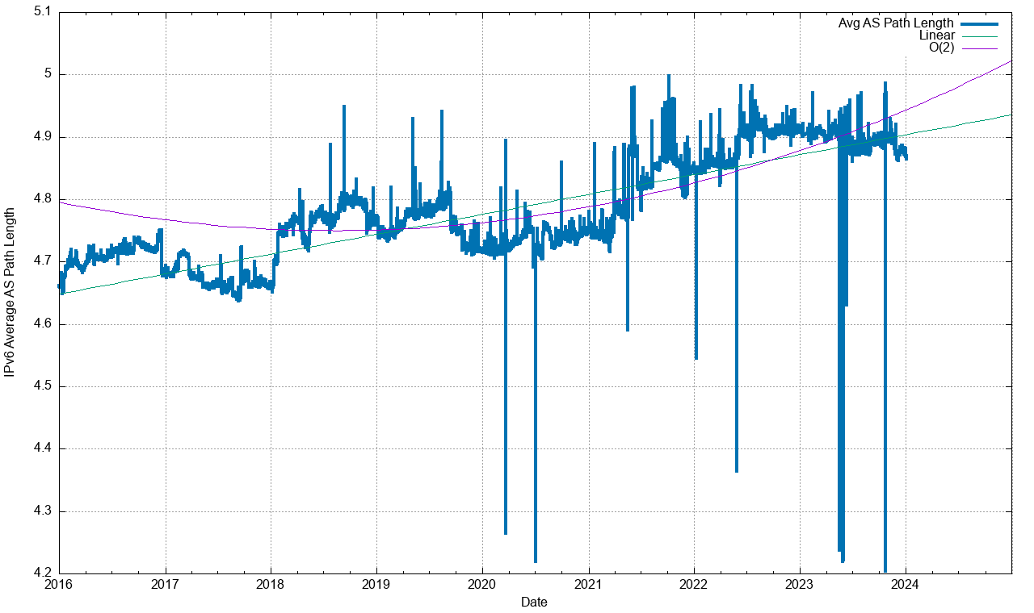

*Figure 16 – Average AS Path Length of BGP IPv6 prefixes*

*Figure 17 – Distribution of AS Adjacencies in the V6 network*

These similar profiles of inter-AS topology would support a conclusion that the IPv4 and IPv6 BGP system should behave in a reasonably similar manner.

However, in making such generalisations the distributions of updates shown in Figures 12 and 13 need to be remembered. When we are talking average update volumes, we are actually talking about a very small set of prefixes that generate anomalously high volumes of updates. It is probably more accurate to say that “the small number of anomalously unstable prefixes in IPv6 exhibit relatively higher levels of instability than their IPv4 counterparts.”

### Instability and Update Types

We can look further into these updates to see if there is any visible correlation between routing practices by network operators and BGP instability. If we look at just those updates that refine an already announced address prefix, then we can use a taxonomy of the effect of the routing update. The taxonomy used here is to look at:

* a change in the *Origin AS*,
* a change in the *Next-Hop AS* (the next AS in the AS Path that is adjacent to the origin AS),
* a change in the *AS Prepending* of the AS Path,
* any other changes in the *AS Path*, and finally
* a change in the non-AS Path attributes of the update.

The profile of the daily count of these updates for IPv4 is shown in Figure 18 for IPv4. Changes to the origination of prefixes is the least common form of update, which the most common changes are related to internal topology changes in the network (AS Path change) and changes in stub-to-transit connections (AS Next Hop), which presumably is often related to traffic engineering.

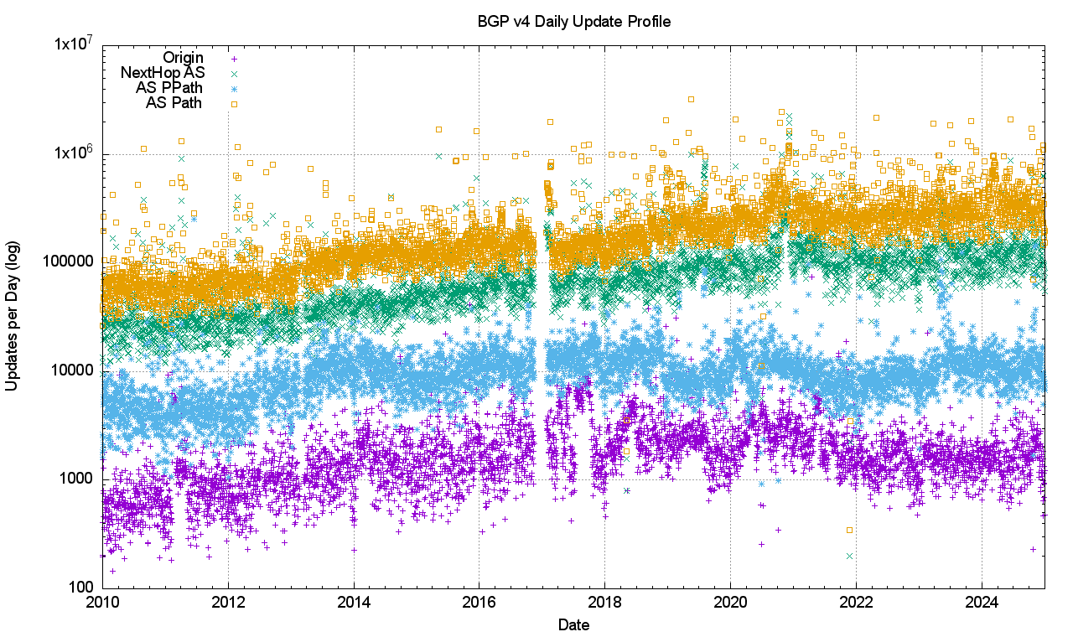

*Figure 18 – Distribution of Update Types in the V4 network*

A very similar profile is visible in the IPv6 network (Figure 19), with AS Path Changes and AS Next Hop changes being a major part of the update profile.

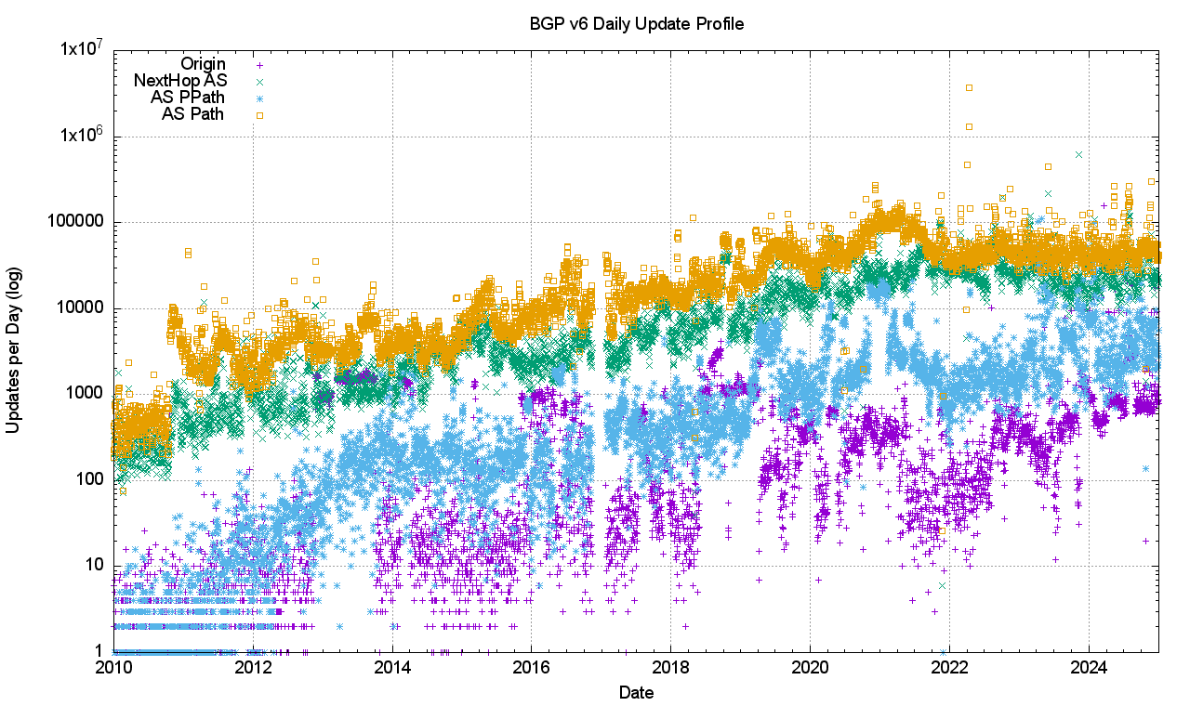

*Figure 19 – Distribution of Update Types in the V6 network*

Another way of looking at this data is to remove the absolute volume of updates and look at the update types as a proportion of the total number of updates seen each day (Figures 20 and 21).

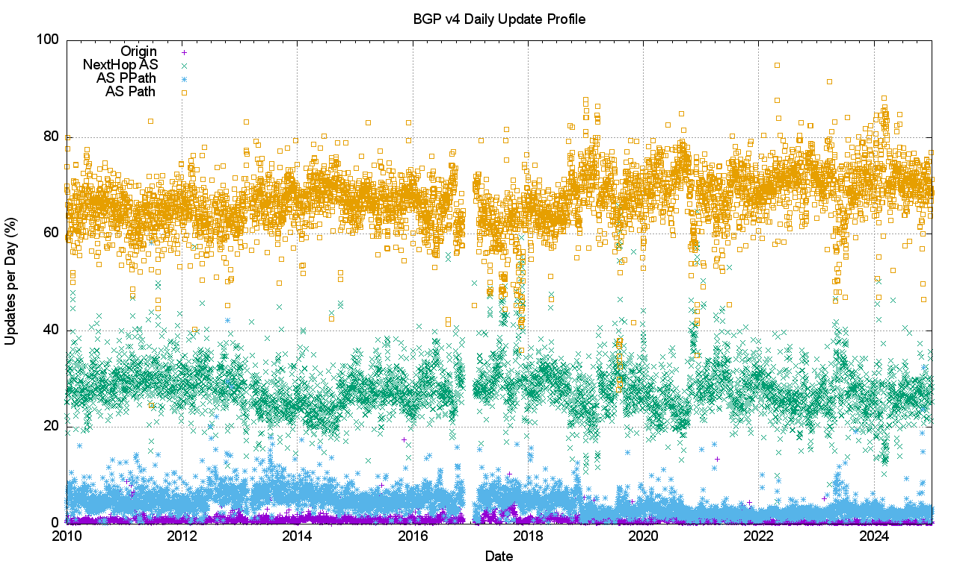

*Figure 20 – Relative Distribution of Update Types in the V4 network*

*Figure 21 – Relative Distribution of Update Types in the V6 network*

In IPv4 most (70%) of the BGP updates describe changes in the AS Path. Slightly less than 30% of the changes occur with the Next Hop AS. IPv6 shows a similar update profile, with a slightly higher of day-to-day variation.

It is likely that much instability is due to BGP oscillation when negotiating routing policies relating to multiple paths. As a distributed algorithm, BGP itself is not a deterministic process, and when the protocol is attempting to negotiate a stable outcome between the BGP preferences of BGP speakers announcing reachability across multiple egress paths, and BGP listeners applying local preferences across a number of ingress paths, then some level of instability is expected. Indeed, what is perhaps most surprising here is that the volume of these BGP updates is so low, particularly when the underlying topology appears to show such a rich level of interconnection. When a BGP environment becomes unstable and flips between multiple local states that are all equivalent, one might expect that the BGP update rate would increase uncontrollably. What mitigates this situation is BGP’s MRAI damping interval. BGP will only emit updates every MRAI seconds, and only pass on the current state of each updated prefix at that time, damping out any form of higher frequency local route oscillation. The commonly used value of 27 – 30 seconds (varied randomly each MRAI interval) is the most likely explanation of why BGP appears to be so well behaved in terms of update rates.

The cost of this MRAI timer is reflected in the average time to route convergence, which is steady at 50 seconds in IPv4 (Figure 4) and varies between 40 and 50 seconds in IPv6 (Figure 11). From time to time the discussion takes place on reducing the MRAI timer value for all eBGP speakers. Such a change could possibly result in faster average convergence times, but what is not so clear is the exact nature of the relationship between MRAI timer settings and overall BGP update volumes. It is likely that the widespread use of a smaller MRAI timer in the eBGP environment would result in an increased volume of BGP updates.

### Instability and Traffic Engineering

BGP is used for two functions. The first is the maintenance of the network’s inter-domain topology. BGP ‘discovers’ the set of reachable networks through the conventional operation of a distance vector-style distributed routing protocol. It’s not that every BGP speaker assembles a complete map of the connected state of the network. BGP’s objective is slightly different, in that each BGP speaker maintains a list of all reachable address prefixes and for each prefix maintains a next hop forwarding decision that will pass a packet closer to its addressed destination.

The second part of the use case can be more challenging. BGP is used to negotiate routing policies, or so-called “traffic engineering”. If a network is connected to two upstream transit providers and one offers a lower price than the other, then the local network may well prefer to use the lower cost network for all outgoing traffic, all other things being equal. There is also the issue of incoming traffic that needs to be considered, so the local network operator would like to bias the route selection policies of all other networks such that the lower cost transit network is used to reach this local network. Outgoing traffic can be groomed to match local policies by using local policy settings in the interior routing space, but incoming traffic can only be ‘groomed’ by using BGP to bias other networks’ route selection policies. There are a number of ways of achieving this, but the basic observation is that if you wish to groom incoming traffic according to a number of different policy settings then you need to advertise a collection of address prefixes to be associated with each policy setting. The most common routing practice is to advertise the aggregate route set to all adjacent peers, and then selectively advertise more specific routes to some adjacent peers in order to implement these routing policies. What we would expect to see in this scenario is that the aggregate routes and the more specifics may well have differing AS paths, but they would share the same origin AS.

A variant of this form of traffic engineering exploits the fact that the BGP route selection algorithm will prefer shorter AS paths when all other factors are equal. A BGP speaker may elect to artificially increase the AS Path length on the less preferred ingress path by adding repetitions of its own AS to the AS Path to the less preferred eBGP peer. Any form of instability in path selection between these multiple ingress paths would be reflected as a set of updates that retain the same origin AS and even the same next hop AS and retain the same sequence of AS’s in the AS Path, but the paths differ across successive updated in the amount of AS prepending contained with the path.

A somewhat different scenario occurs when an end site uses an address prefix from a provider’s address block but wants to define a unique routing policy. In this case the end site would use its own AS number, so that the aggregate and its more specific would use different origin AS numbers.

It is also possible that the network operator is advertising more specific routes as a means of mitigating, to some small extent, the impacts of a hostile route hijack. In this case the aggregate route and the more specific would share a common origin AS and a common AS Path.

We can look at the route table to see the prevalence of each of these types of advertised prefixes. Figure 22 shows the relative proportion of the prevalence of each of these four types of route advertisement:

* a “**Root**” prefix which has no covering aggregate,
* a “**Hole**” prefix where the origin AS of the more specific prefix differs from the origin AS of the covering aggregate,
* a “**Path**” prefix where the more specific prefix shares the same origin AS, but has a different AS Path, and
* a “**More-Specific**” prefix where the AS path of the more specific and the covering aggregate are the same.

*Figure 22 – Relative Distribution of Prefix Types in the V4 network*

Over the past decade the proportion of *Root prefixes* has declined slightly, as have *Path prefixes* (different-path more-specific), while the number of *Hole prefixes* (different origin) has risen slightly. Over 2024 the relative proportion of *Root prefixes* has fallen slightly, while the number of Hole prefixes has risen by a similar amount.

A comparable view of the IPv6 network (Figure 22) shows a similar result in the profile of prefixes as of the end of 2024, but with very different starting conditions. In 2012 the level of route fragmentation (announcing more specifics of existing aggregate announcements) was less than 25% of all prefix advertisements. Over this period, the relative incidence of Root prefixes has declined from 75% to 45%, while the number of Hole prefixes has risen to 40%. A possible explanation is that as IPv6 has changed from being a low-use trial platform to become part of the service environment, then the considerations of traffic engineering have risen in importance. This data points to the emerging picture of handling IPv6 addresses in a similar way to that used for IPv4, where there is a widespread use of more specifics for both traffic engineering and as a rudimentary form of prefix-hijacking defence.

*Figure 22 – Relative Distribution of Prefix Types in the V6 network*

Are each of these prefix types equally likely to be the subject of BGP updates? Or are some prefix types more stable than others? An intuitive guess would see Root prefixes being more stable than traffic engineering prefixes, as would the Hole-punching more specific prefixes. The other two types of more specific prefixes should be more likely to be unstable.

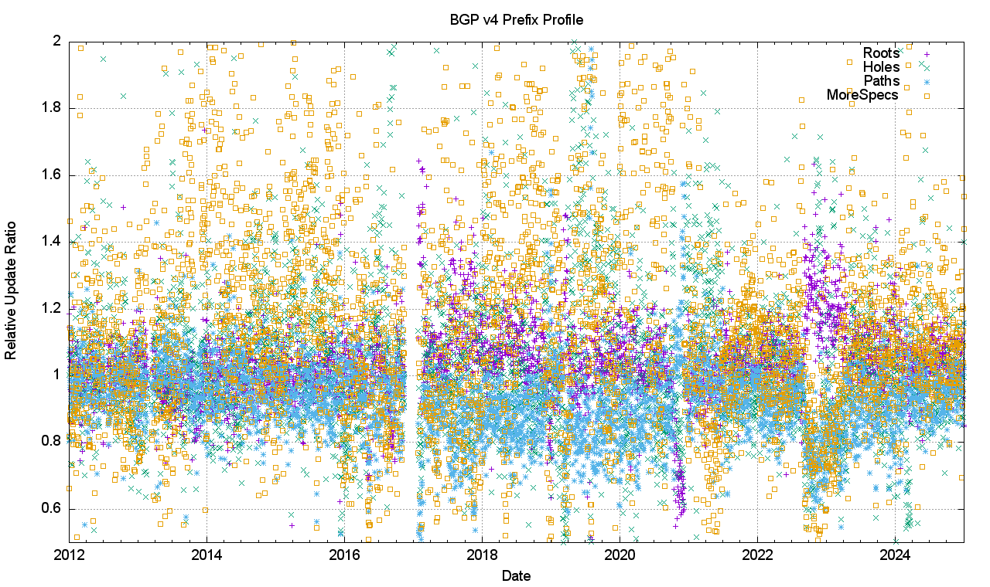

*Figure 24 – Relative Distribution of Prefix Update Types in the V4 network*

Figure 24 shows the day-to-day calculation of the relative proportion of BGP instability by each of these four prefix types. It plots the number of updated prefixes per day of each prefix type, as a ratio of the total number of updated prefixes of that type. If the likelihood of a prefix being updated was completely random, then the type of prefix being updated would correlate with the relatively population of that prefix type, and all four types would have a relative update ratio of 1. Prefix types with a relative update ratio less than 1 are less likely to be updated compared to the other prefix types. Figure 24 is a relatively noisy picture, but some general trends are visible. *More-specific prefixes* are more likely to be updated (i.e. have a daily ratio greater than 1), while *Hole prefixes* are relatively more stable (i.e. have a daily ratio less than 1).

The same analysis has been applied to the IPv6 network (Figure 25).

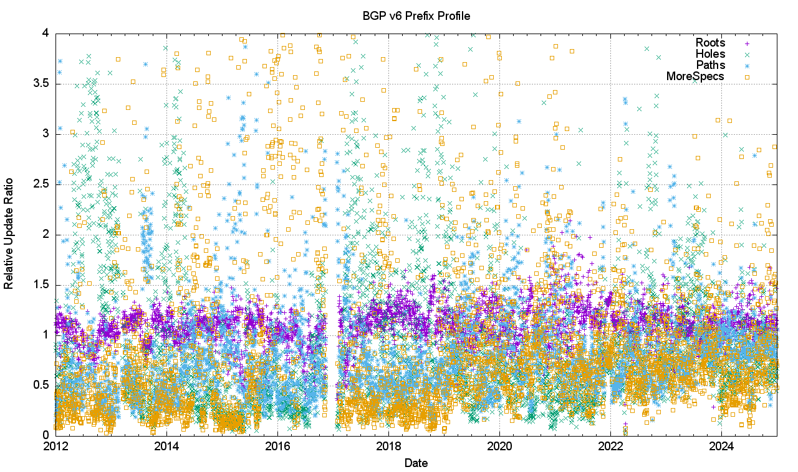

*Figure 25 – Relative Distribution of Prefix Update Types in the V6 network*

There is a stronger picture of the various update ratios converging to a value of 1 in IPv6 over time. The various types of more specific prefixes are still slightly more stable than root prefixes.

## Conclusions

None of the BGP churn metrics that we have reviewed here indicate that we are seeing an unsustainable level of growth in the routing system that it will fundamentally alter the viability of carrying a full BGP routing table anytime soon.

The BGP update activity remains relatively stable in both the IPv4 and IPv6 domains. The *clustered* (or centralised) nature of the Internet, where the diameter of the growing network is kept constant while the density of the network increases has resulted in the situation where the dynamic behaviour of BGP, as measured by the average time to reach convergence, has remained very stable in both IPv4 and IPv6.

The incidence of BGP updates appears to be largely unrelated to changes in the underlying model of reachability, and more related to the adjustment of BGP to match traffic engineering policy objectives. This pattern of BGP updates is not a source of any great concern at this point in time.



### Disclaimer

The above views do not necessarily represent the views or positions of the Asia Pacific Network Information Centre.



### Author

*Geoff Huston* AM, B.Sc., M.Sc., is the Chief Scientist at APNIC, the Regional Internet Registry serving the Asia Pacific region.

[*www.potaroo.net*](http://www.potaroo.net)